Competente word
Anul 2019
Varianta1
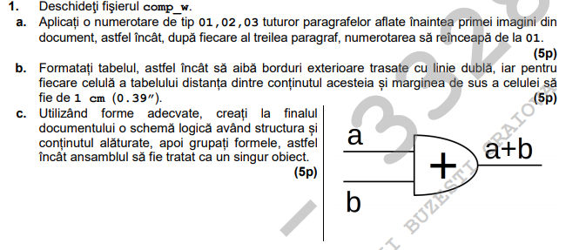
Varianta5
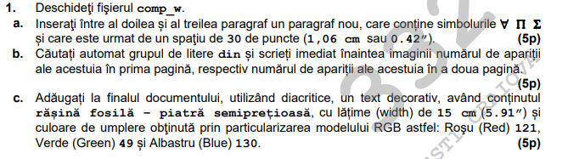
Model
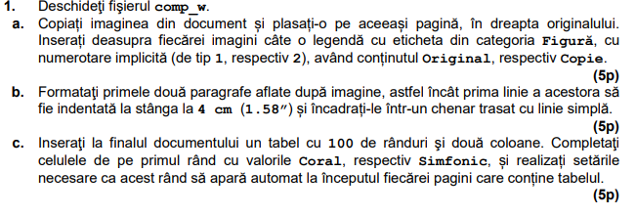

Anul 2018
Varianta4
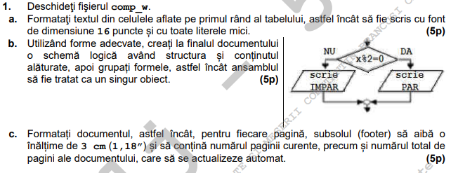
Varianta3
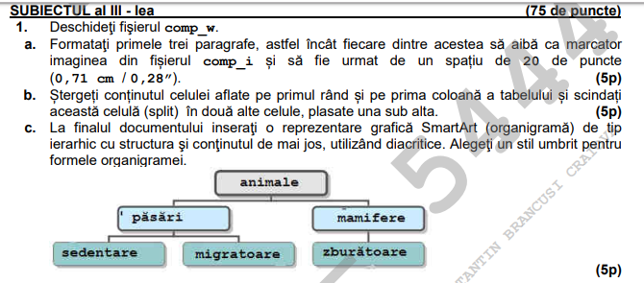
Varianta5
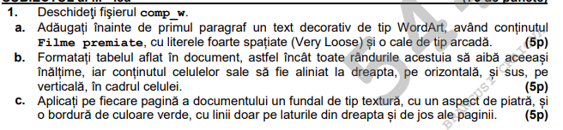

Model
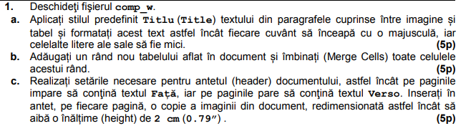
2017
Varianta 5
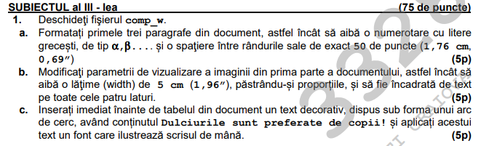
Varianta 3
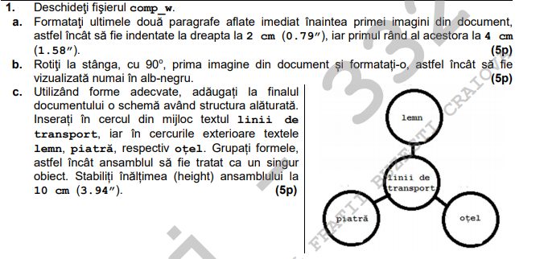
2016
Varianta 14
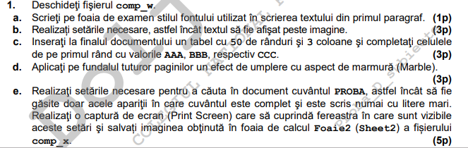

Varianta 4
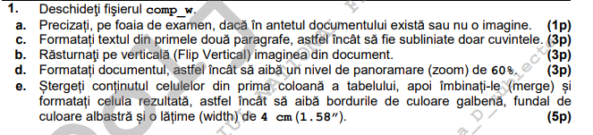

Model
